Year In Review
Alex Shvartsman
This was an exciting year, with plenty of stories to add to the ongoing saga of professional Magic. Let us review the happenings of 2001 month by month, followed by some predictions for the next year.

January
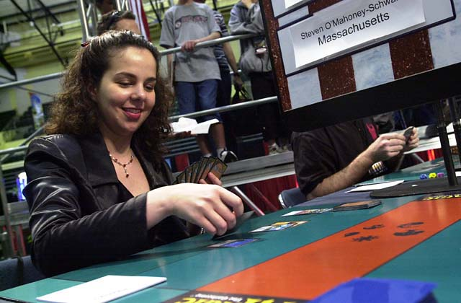
The Invasion Limited season had begun. Because of Pro Tour-Columbus being removed from the 2000-2001 season roster, there would be two Limited seasons in a row, to the joy of many pro players who prefer drafting to any other form of playing Magical cards. Grand Prix-New Orleans was the first event of the year, the Cajun city luring the more party-minded players with promises of some excellent nightlife. Bill Stead won the tournament, but it was the finalist Michelle Bush who stole the spotlight, becoming the first female player to place in the Top 8 of an individual Grand Prix.
For those who did not get enough partying done in New Orleans, the next weekend was tailored for more, with GP-Amsterdam. Perhaps the most popular GP location in Europe, this third Grand Prix to be held there gathered nearly 700 players from all over Europe and some from United States. It was here that Chris Benafel has broken his curse of always finishing in the second place, finally earning the top finish. GP-Hiroshima was the final event of the month. Local turnout was solid, but few international players turned out because Pro Tour-Los Angeles was only a couple of days away. Japanese national champion Masayuki Higashino defeated Masaya Mori to win the trophy there.

February
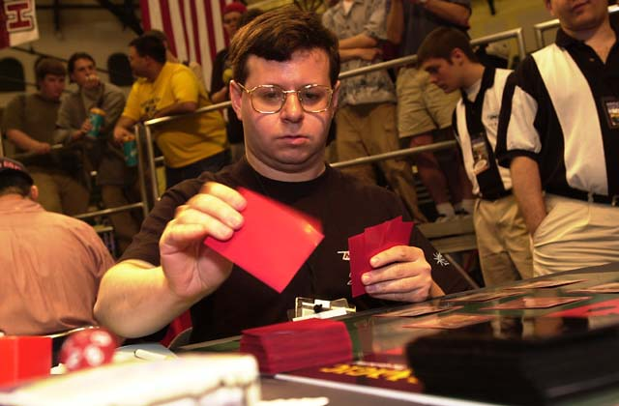
Michael Pustilnik took home the gold at the Rochester Draft Pro Tour in Los Angeles. A veteran player from New York, Pustilnik had two previous Pro Tour Top 8 finishes, including one at PT-Chicago in December 2000. Pustilnik was not the only player to earn back to back Top 8's on the Boat - Jon Finkel and Kamiel Cornelissen both reached the single elimination rounds as well. At the time, the debate raged across the tournament community as to whether Cornelissen might challenge Finkel as the best player in the game. Budde was just reaching the end of his year-long dry spell and would not join the race until a few months later in the year. Cornelissen however seemed like a top contender, as he busted onto the Pro Tour with a string of very impressive finishes and became a finalist both at PT-Chicago and PT-Los Angeles, defeating Finkel in both of those Top 8's. A number of other well-recognized names earned Top 8 finishes, including Kyle Rose and Benedikt Klauser. Lawrence Creech's Top 8 performance put him in the lead of the Rookie of the Year race.
Sadly, this was the last Pro Tour to ever be held on "The Boat" - The Queen Mary - permanently docked in Long Beach, CA and turned into a hotel. There had been a total of six Pro Tour events there and it was the favorite tournament location for many veterans of the game. Later in 2001 however, the conference hall area on Queen Mary would be closed for renovations and restructured in such a manner that would end up preventing events as large as the Pro Tour from being held there. This was why the next West Coast PT will take place in San Diego.
Two Limited Grand Prix were held simultaneously the weekend after PT-LA. Ricard Tuduri defeated Olivier Ruel in Valencia, Italy, while Tobey Tamber won in Kaohsiung, Taiwan. An American player, Tamber has always enjoyed Taiwan and traveled there several times. A few months prior to the GP, he moved there and got a job teaching English. This allowed Tamber to travel to a number of GP events in Asia and earn several Top 8 finishes, Kaohsiung (pronounced Gao-sh-ung) being his first win.
Another Ruel brother played in the finals a week later, in Cologne, Germany. He too was defeated. Jim Herold earned his third Grand Prix victory, joining Kai Budde, Steve O'Mahoney-Schwartz ad Jon Finkel as the only players to hold that honor at the time. Meanwhile, Tom Swan, father of Brad Swan, defeated Scott Johns in GP-Boston. Johns finally broke his "Grand Prix curse" earning a top finish.

March
For the third time in a row, there were two Grand Prix played at the same time on different continents. Ryan Fuller won in Prague defeating Jens Thoren, while Carlos Romao managed to keep the trophy in his country, defeating me in the finals of GP-Rio de Janeiro.
Jos Shreurs from The Netherlands won GP-Gothenburg, Sweden a few weeks later. Finally, Matt Vienneau won GP-Detroit on the last weekend of the month, his second GP win in Invasion Limited.
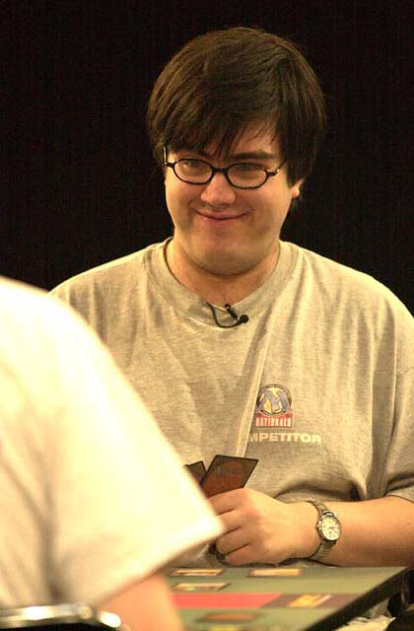
The important event of the month was, of course, Pro Tour-Tokyo. For the second PT in a row, New York won the title, with Zvi Mowshowitz earning his first PT win. Zvi played a blue-white weenie deck titled "The Solution" and designed by John Ormerod that performed extremely well in the metagame heavily slanted toward r-g. Mowshowitz defeated Tsuyoshi Fujita in the finals, who became the first Pro player from Asia to earn a Pro Tour Top 8. The most successful group of players that weekend was team AlphaBetaUnlimited.com. They fought their way through the Gateway tournament to qualify for the Masters series and won that event. They also placed Ryan Fuller, Chris Benafel, Lucas Hager, and Philip Freneau in the Top 8, making it the best weekend in their team's career. Fuller also set another record by being the first player to ever go undefeated through the entire Swiss portion of the Pro Tour, winning 14 rounds in a row.

April
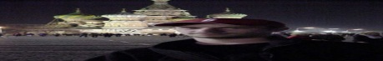
Tournament players got a chance to take a break in April. There was only one Grand Prix this month - in Moscow. This was scheduled as a Standard tournament that would qualify players for PT-Columbus. Since that Pro Tour was cancelled, most Grand Prix for the season were either cancelled (explaining the uneventful month of April) or switched to Limited. GP-Moscow was the only event to survive the purge, and its format was changed to Invasion Block Constructed.
Ryan Fuller, fresh off a win in Prague and a great run in Tokyo, displayed his mastery of the Grand Prix circuit once again, winning in Moscow. All Pro players who attended the event had a tough choice to make - play their best deck to increase the chances of winning, or play a tier-two deck and hide the really good stuff until Pro Tour-Barcelona, where Invasion-Planeshift constructed would be a Masters Series format. Fuller and the Ruel brothers played their u-w-b Dromar control deck, which they would later use in the Masters.

May
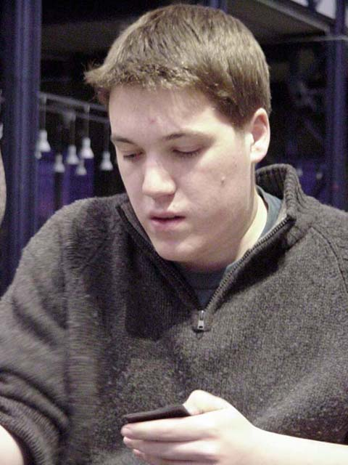
Year of the Kai officially began in the early days of May, when he defeated Alan Comer in the finals of booster draft Pro Tour-Barcelona. If it was up to Budde, he would have never played this final match though. He offered to concede to his roommate Patrick Mello when they faced each other in the Top 4. This was extremely generous of Kai. By winning this Pro Tour he would have made history - becoming the first player to ever win three Pro Tours and likely the first player to ever earn the Player of the Year title twice. However, he was willing to forgo that to help his friend gain the additional Pro points needed to get on the Masters Series. The judges did not allow the concession, so Kai had to 'settle' for winning the PT instead. Albertus Law of Singapore became the second Asian player to earn a Top 8 finish, while Yuri Kolomeyko became the first player from the former Soviet Union (Ukraine) to hold that honor.
Meanwhile in the Masters, Ben Rubin earned his second win. Although he was having a very poor year on the Pro Tour (toward Worlds, Rubin would struggle to remain on the gravy train, though he would overcome that and regain a solid PT standing toward the end of 2001), he was also one of the top money-earners in the 2000-2001 PT season due to the two Masters wins.
May also signaled the start of the Team Limited season, a season that would come to be dominated by team ABU, in its various forms. Fresh off the win in Tokyo, ABU substituted Noah Boeken by Dave Williams and won Grand Prix-Yokohama. They then made the finals but lost to Dan Clegg, Brock Parker, and Peter Szigeti in Grand Prix-Turin.

June
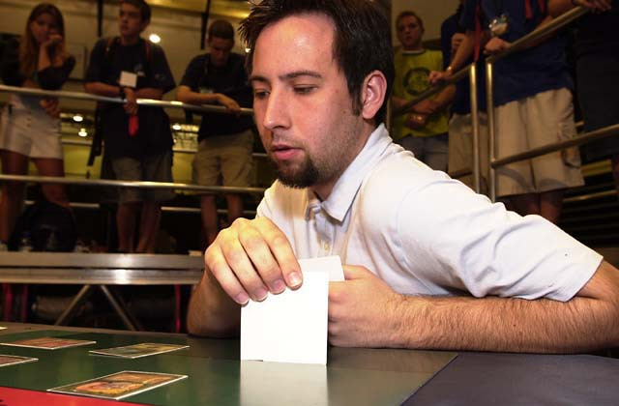
Players took a two-month break from the Grand Prix circuit to participate in National and Continental championships. Since North America does not have a Continental Championship tournament, U.S. Nationals commends the attention - and the prize money - normally due to one. This time around the two dominant archetypes in Standard proved to be Fires and u-w control - which met in the finals of U.S. Championships to no one's surprise. Trevor Blackwell defeated Brian Hegstad, so the top slot went to the Fires deck. Eugene Harvey battled his way into a third place finish, and a spot on the U.S. National Team.
U-w got its revenge a few weeks later at the Asian-Pacific Championships, where it was the dominant deck in the Top 8. Japanese players once again outdid the rest of the region, and it was the two Japanese - Jun Nobushita and Jin Okamoto, who played for the title, with Okamoto winning the match.
Another archetype dominated two other continents, when Latin and European championships took place at the end of the month. In Europe, Eivind Nitter brought the title to Norway for the third time, having defeated Dave Montreuil - a Canadian living in Switzerland. Nitter played a Counter-Rebel deck, re-emerging as a victor of a major event for the first time after its strong performance in PT-Chicago. Montreuil played a monored beatdown deck. In Mexico, Scott Richards won with yet another Counter-Rebel deck. Like Monteruil, Richards is not a native of his region. He is a New Zealander currently living in Uruguay. Richards's performance in LAC helped him earn an invitation to the Magic Invitational as a representative of South America.

July
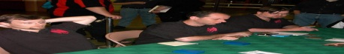
National Championship season was winding down, and the pros fit in several more Grand Prix while practicing for Worlds. ABU won again in Taipei (featuring the roster of Williams, Clegg, and Benafel). In Columbus, the old favorite Your Move Games (Kastle, Dougherty, Humpherys) defeated Ken Ho, Lan Ho, and Dan Clegg (who seemed to help any team he joined that season to perform admirably).

August
World Championships wound up an exciting season. Jan Tomcani of Slovakia won day one with a Fires deck - a record that helped him earn a Top 8 finish in the end. Brock Parker went undefeated and had strong enough tiebreakers to win the draft day, and Alexander Witt won the Extended day with his white weenie deck. U.S. National team performed poorly over the three days of individual play, making fans wonder whether U.S. would relinquish its dominance over the team title for the first time in years. This was not to be. Americans rallied on the fourth day of the competition, guaranteeing themselves a slot in the playoffs, and defeated Norway to keep the trophy yet again.
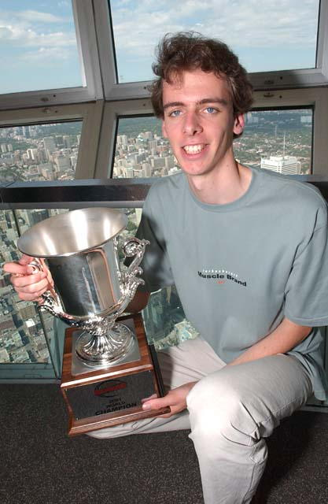
In the individual competition, Netherlands's Tom Van de Logt defeated recently discovered American pro Alex Borteh to become the 2001 World Champion. Kai Budde was crowned Player of the Year to no one's surprise, leaving Jon Finkel and Kamiel Cornelissen still battling it out for second best, in public opinion if not Pro points. In a much closer race, young Japanese player Katsuhiro Mori edged out Lawrence Creech and Ken Ho to win the Rookie of the Year title by placing in the Top 16 of Worlds.
The tournament was only marred by the disqualification of David Williams during the Top 8. Judges felt that he took advantage of several marked Accumulated Knowledges in his deck, which earned Williams a one year suspension from DCI events. With several high profile cases like this one, DCI cracked down on players suspected of wrongdoing in 2001 more so than ever before.
This World Championship ended the first season since the additional prize money have been added to the Pro Tour circuit. The results have been very encouraging, as we saw PTQ and Grand Prix attendance rise significantly, and the level of competition increase.
Later in August, the 2001-2002 Pro season was kicked off with the first Invasion Block Constructed Grand Prix in Denver and Kobe, Japan. Brett Shears won in Denver playing a b-g-u control deck, but it was GP-Kobe that excited the spectators with its mammoth attendance record. It was the largest Magic tournament ever, at 1350 participants. As a matter of fact, Grand Prix trial that took place a day prior, probably had more people in it than Grand Prix-Denver! Itaru Ishida won this tournament with a u-w-r Goblin Trenches deck pioneered by Ben Seck in a qualifier held at the World Championships. Matias Gabrenja from Argentina won a much smaller GP-Santiago, Chile a week later.

September
Players were getting ready for Pro Tour-New York, but it did not prevent many from traveling to IBC Grand Prix in Singapore and London the week before. Singapore's top player, Albertus Law, used a Counter-Trenches deck to win on his home turf, while Kai Budde earned his fourth GP win (and yet another record on his resume) by winning GP-London with a Domain deck. He defeated newcomer Gabriel Nassif, who he would soon have an opportunity to face again. GP-Warsaw, Poland was held on the same weekend as Pro Tour-New York. Richard Osterberg won it playing a NoMar deck.

Kai Budde could not be stopped. He turned down a number of attractive offers, choosing to team up with local players. So what if Dirk Baberowski quit competitive Magic, or that one time German national champion Marco Blume isn't well known outside of his country? Budde had no doubts - and his team proved more than solid, winning Pro Tour-New York. In the finals, they defeated Gabriel Nassif's team of little-known French players, who nevertheless managed a Day 3 finish. Their second place finish placed Amiel Tenenbaum in the lead of the Rookie of the Year race, which he would retain throughout the remainder of 2001. Other Top 4 teams included Car Acrobatic Team - for the second year running, CMU's Aaron Forsythe, Andrew Johnson, and Andrew Cuneo earned a top finish. Finally, my own team Illuminati rounded off the top 4 - featuring Zvi Mowshowitz, Justin Gary, and yours truly.
Our triumph was short-lived, as the September 11 attacks put the thoughts of the Pro Tour behind us all for a while. A number of players who stayed in New York a bit longer to sightsee got stuck in the city, but thankfully none were hurt.
Two more IBC GPs were held in September. Trey Van Cleave won in Oslo playing a u-b-w Desolation Angel deck, while Dave Humpherys defeated Andy Wolf in Minneapolis with a similar deck. Oslo was the first European Grand Prix in a very long time where no North American players attended. It was partly due to the September 11 attacks, and partly to the high airfare prices.

October
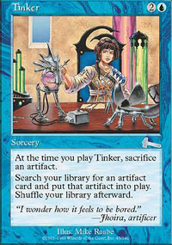
The first weekend of October was very busy, with two Grand Prix and the Magic Invitational. As usual, Invitational was one of the most talked about events of the year. Organizers outdid themselves to place it in the most exotic location yet - South Africa - allowing even the hardened travelers like me to visit some place really new. In the end, and to no one's surprise, it was Budde again to won the right to make his own Magic card. He defeated Dan Clegg in a marathon final, which lasted over six hours. It was somewhat anti-climatic in the end, as Budde managed to win the deciding game by Tinkering for a Jeweled Bird.
The first of the Odyssey Limited Grand Prix were held the same weekend, with Australia's Ben Seck winning in South Africa and Germany's Stephan Meier winning in Vienna. Mike Turian won Montreal and Kehei Yamadaya won Shizuoka a weekend later. Richard Johnston kept the trophy home by defeating me, and New Zealand's Roger Miller in the final rounds of GP-Brisbane yet another week later.

November
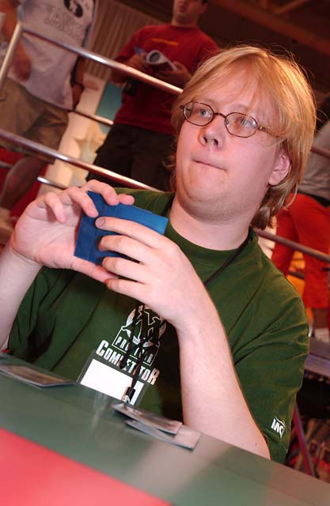
Pro Tour-New Orleans was very exciting - featuring the total reinvention of the Extended format. New and fun archetypes abounded, but it was the same old Kai who took the gold again. Budde played a modified Donate deck, splashing red mostly for Pyroblast and Fire/Ice. He defeated Tomi Walamies in the finals, who played an original control deck featuring a cool Intuition/Call of the Herd combo.
This tournament was also a rally for Team Your Move Games. They had a mediocre year with few top finishes, but here Kastle and Humpherys both navigated Dougherty's deck to Top 8 finishes (Dougherty himself placed in Top 16).
In the Masters Series, Mike Pustilnik defeated Chris Benafel in the finals, becoming the first player ever to win Masters, Pro Tour, and a Grand Prix. After his win of GP-Las Vegas in December, he could also boast that he won each type of event in the same year.
With the summer over, Grand Prix were back with a vengeance! Jeff Fung, who has not been heard from after his Top 8 finish at PT-Chicago years ago, came out of nowhere to win Grand Prix-Hong Kong. That same weekend, Team CMU reaffirmed their dominance over the format when Eugene Harvey defeated teammate Andrew Johnson in the finals of GP-Atlanta. Kai Budde actually lost in the finals a weekend later, defeated by Nicolas Labarre at GP-Biarritz. This is only the second time Budde lost in the single elimination rounds, the first being to Bram Snepvangers about a year earlier.

December
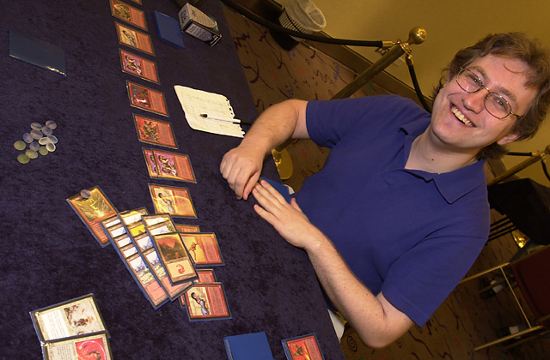
As the year wound down, an Extended qualifier season began with Grand Prix in Vegas and Curitiba. In Brazil, Guilherme Svaldi used an original 5-color green deck to defeat me, playing a Finkula deck. Meanwhile, Pustilnik won Grand Prix-Las Vegas with a copy of "The Rock and his Millions" - a pet deck of Sol Malka.
Kazuaki Arahori further muddied the waters of an Extended metagame by winning Grand Prix: Sendai with a strange u-b Zombie Infestation control concoction. Mike Long placed third in that tournament, using a modified version of Alan Comer's Miracle Grow deck, helping make this the most popular archetype in qualifiers for the rest of the year and into January

It was a very exciting year, with 35 Grand Prix, six Pro Tours and countless other tournaments. What interesting developments can we look forward to in 2002? Here are a few of my predictions for the new year:
Magic Online will significantly increase the number of tournament players

There are something like seven million Magic players in the world, and only a small portion of them competes in sanctioned tournaments. In addition to being great fun, Magic Online will also serve to educate many of them about organized play, as well as introduce countless computer game fans to the game. In the long run, this should further increase tournament attendance, and we can start seeing the results as early as the next autumn.
Price of single cards will drop slightly
Over the last two years, single card prices in the secondary market rose significantly. An extremely strong Japanese market drove this. Japan's economy is in trouble, and the yen has dropped drastically against the dollar. This will result in lower prices there - and the rest of the world in the long run.
Kai Budde will lose on a Pro Tour Sunday
Kai will undoubtedly continue to post very strong performances at PTs. He will very likely place in Top 8 of at least one Pro Tour this year, probably more. However, there is SOME luck in Magic, and his streak of never losing once he makes Top 8 will be broken.
Netherlands will dominate European Magic scene
Over the last year and a half Netherlands have emerged as one of the best places in the world to play tournament Magic. Cornelissen, Van de Logt, Boeken, Wiegersma and many, many more top Pro players hail from this country. Germany, France, United Kingdom and the Scandinavian countries have a lot to offer as well, but I expect Netherlands to lead in Pro Tour performances, second only to United States.
MiseTings.com will replace The Dojo in the hearts of Magic players

In the age of commercially dominated web sites, MiseTings.com is the first really great Magic web site in ages that does not pay for submissions yet gets plenty of high-quality ones and is maintained for love rather than money by pro player Mike Bregoli.
Eastern Europe to play a greater role
More pro players will emerge from the countries of the former Soviet Union as well as Poland, Czech Republic and other Eastern European countries.

